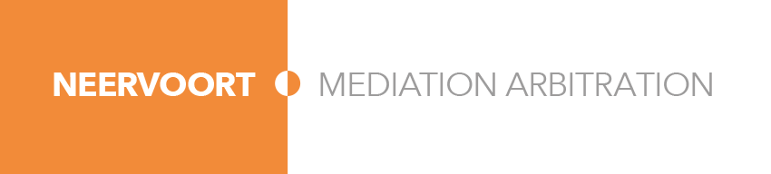
Neervoort, Bart
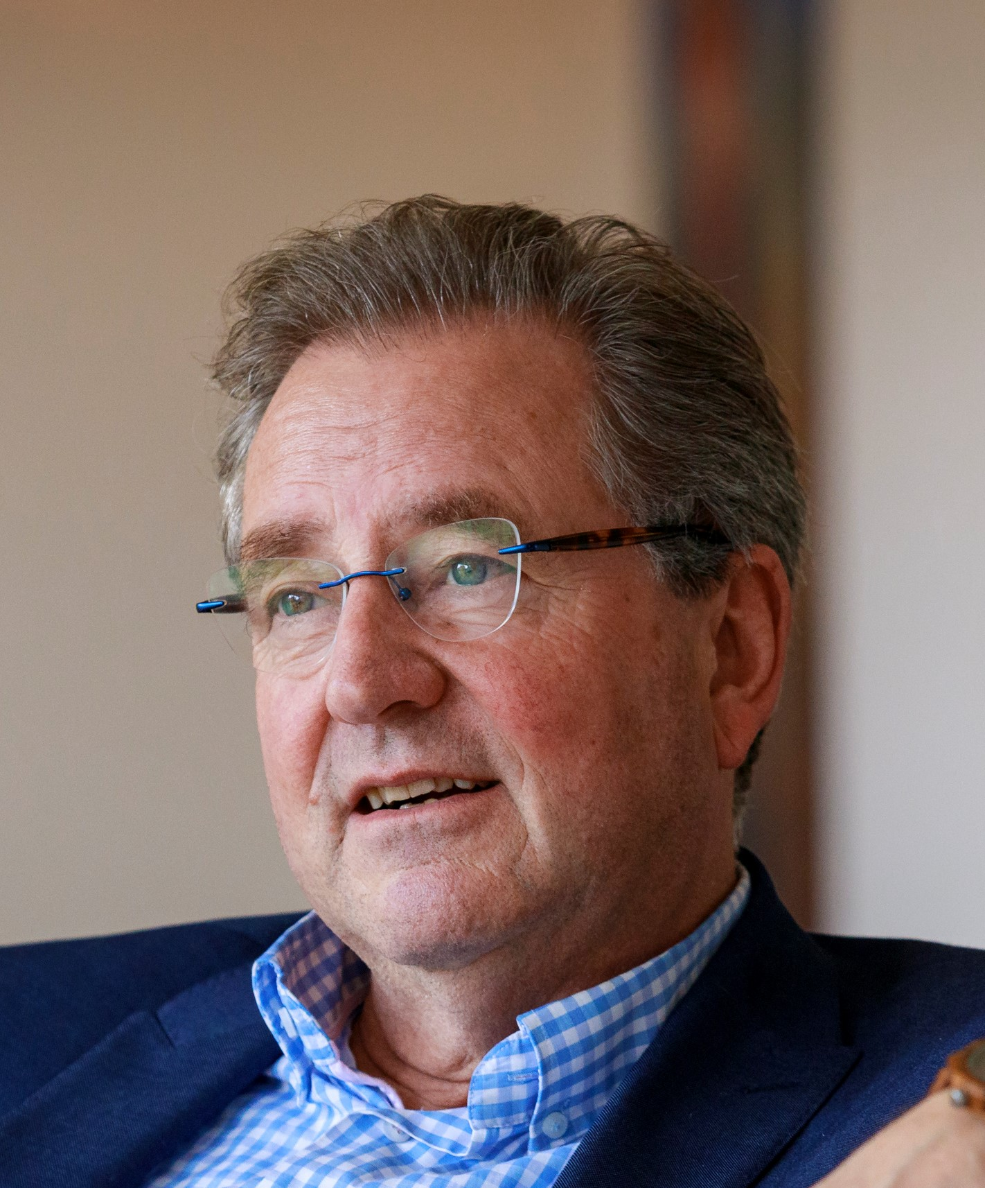

Personal data
Surname NEERVOORT
Given name Bart
Initials W.G.B.
Date of birth 1 October 1953
Place of birth Lagos, Nigeria
Nationality Dutch/English

Contact details
Address Meikevermeent 19, 1218 HB Hilversum Netherlands
Cell phone +31 6 53 202437
Website www.med-arb.nl
E-mail neervoort@med-arb.nl

Experience
2020 – present Honorary Appeal Court Justice Court of Appeal, the Hague
Netherlands ((civil and commercial chambers)

2009 - present National and international mediator and arbitrator
(Yearly average of 40 mediations and 5 arbitrations in corporate & commercial-, maritime/transport-, construction-, international trade-, distribution/agency-, liability and insurance- matters)

2007 - 2015 Honorary Appeal Court Justice Court of Appeal, Amsterdam,
Netherlands (civil and commercial chambers)
2000 - 2007 Van Traa Advocaten, Partner (litigation and arbitration,
Rotterdam, Netherlands corporate, commercial.)
1983 - 2000 Schut & Grosheide (now DLA Piper) Partner (litigation and arbitration,
Amsterdam, Netherlands international trade, construction
insurance, corporate, commercial
corporate, commercial)

1978 - 1983 Schut & Grosheide, (now DLA Piper) Associate
Amsterdam, Netherlands

1975 - 1977 Leiden University, (law faculty) Associate-lecturer Dutch civil
Leiden, Netherlands procedural law

Education
2019 Advanced mediator skills Training Harvard University, Boston USA

2005 - present Permanent Education Institutes Various courses on Commercial
Mediation and Arbitration

2002 Centre for Effective Dispute Mediator skills training programme
Resolution, London, UK.
1978 - 1981 Amsterdam Bar Association Young Lawyers Training Programme

1972 - 1977 Rijksuniversiteit Leiden, Law (LLM Programme)
Leiden, The Netherlands
1966 - 1972 Willem de Zwijgercollege, Gymnasium
Bussum, the Netherlands

1960 - 1966 Birkenhead School, Birkenhead, UK Primary School

Languages Spoken Written
Dutch Fluent Fluent
English Fluent Fluent
German Fluent Working knowledge
French Working knowledge Working knowledge

Registrations
with ICC (Paris), CIETAC (Beijing), CPR (New York), UNUM, MfN (Rotterdam), and IMI (The Haque)

Memberships
Insolvency Mediation Foundation (founding board member)
ICC Commission on Arbitration and ADR (Netherlands)
Dutch Association of Mediators (NMv))
Platform Business Mediation (PBM)
International Bar Association (IBA) (Committee Arbitration and Dispute Resolution)
Additional Activities

2017 – present Mediator and judge at the annual ICC mediation competition
2013 – present Lecturer Mediation & Arbitration Netherlands Bar young lawyers training programme
2004 - 2007 Chairman Committee A1 International Bar Association
2000 - present Pro bono mediator in local community
1992 - present Regular speaker at IBA Conferences
(London, Berlin, Amsterdam, San Francisco, Auckland, Prague)
1985 - 2005 Lecturer on Dutch civil procedural law for the Dutch Bar
Association Young Lawyers Training Programme

1983 - present Regular speaker at national conferences on maritime and
transport law, international trade, (commodities and documentary credit disputes), construction, litigation, arbitration and ADR.

References
upon request

